Upstart Scotland AGM, 12/6/21 Via Zoom
Report from the Chair
Little did we know when we organised last year’s online AGM, how much time we’d all spend in the coming year squinting at people’s faces in wee squares on a screen. Neither did we expect the book commissioned in early 2020 by Postcards from Scotland to be such a runaway success…
Play is the Way
It was my enormous pleasure and privilege, over last summer, to edit Play is the Way: child development, early years and the future of Scottish education. We’d been able to sign up an amazing line-up of experts to write the fourteen short chapters and, as each one came in, I became more and more excited about the book that was gradually coming together. We can’t thank Falkirk Council enough for letting us use its Play is the Way slogan for our title because I’m sure that’s been a key factor in its success.
The manuscript finally went off to the printers and on 31st October 2020, the first print run of 300 copies was delivered to our publisher Carol Craig in Strathblane and a couple of boxes driven over to me in Edinburgh. It didn’t occur to us to order more, partly because little books about early years education from a small independent publishers wouldn’t usually attract huge sales, and partly because they had to be stored in Carol’s sitting room!
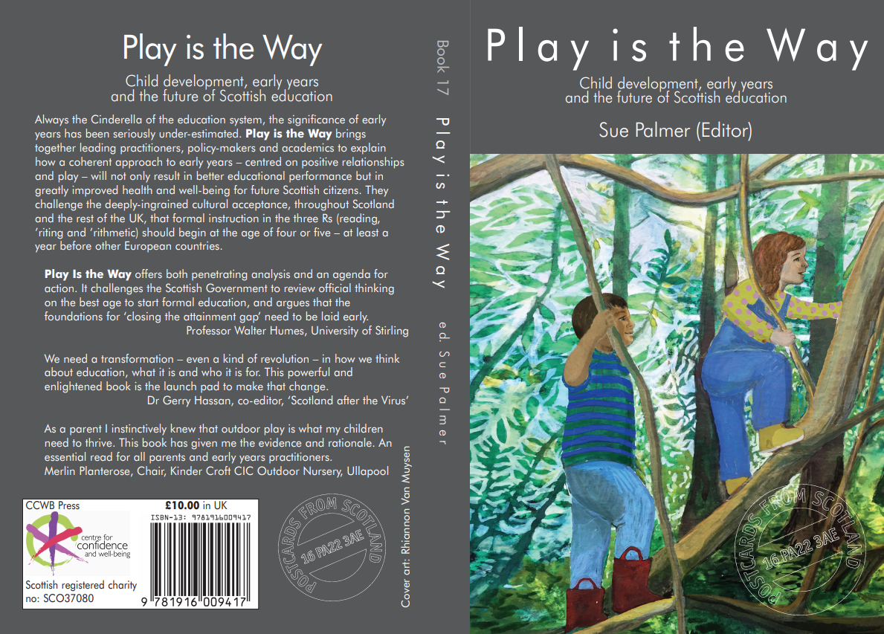
However, our publicity drive on social media over the preceding month had obviously been successful because we had to order a reprint (500 this time) within a week. The copies we sent off to various Scottish ‘opinion formers’ brought praise pouring in from all directions – some of it catalogued on Upstart’s website. I’d also like to send enormous thanks to all the early readers who posted pictures of the book and comments about it on our social media pages, which brought in more orders. Even before the official launch on 14-10-20, we’d commissioned another reprint and were anticipating a third.
Meanwhile, Kate Johnston, our Vice-Chair started a crowd-funded campaign to send a copy of Play is the Way to every MSP and Director of Education in Scotland. She raised the money within a few weeks and on 10-12-20, Kate and I turned up at the Scottish Parliament to deliver the books in plenty of time for Christmas.
By this time we were already contemplating reprint four (1000 – we had to find extra storage space!) – which actually turned into a second edition. Thanks to Play is the Way’s success, we were able to commission another chapter (on Equalities and Diversities), which was written and edited at great speed over Christmas.
In the New Year, orders continued to flood in and we were delighted that Play is the Way was named one of the Books of 2020 in the Scottish Review. In January, we started running Zoom Book Groups (see ‘Online educational events’, below), for which we had to upgrade our Zoom account because they attracted hundreds of participants. The book had by now paid for itself and Upstart is extremely grateful that Postcards from Scotland has given us a generous proportion of the royalties, which should help keep us afloat in these uncertain pandemic times.
At present, our wee book has sold over 3000 copies – a remarkable number for an educational book of this kind in just seven months) and is being read all over the world. A kindle edition, which went on sale in March, has increased international availability. And the section on ‘Scottish Politics and the Parliamentary Election’ below describes the influence it has had here in Scotland. Enormous thanks to everyone who has been involved in producing Play is the Way and helping to disseminate its message.
Online educational events
Our 2020 national conference In the Footsteps of Giants planned for 14-3-20, postponed due to COVID-19 went ahead in September via Zoom, so we were able to see Marjorie Ouvry speak on Froebel, Janni Nicol on Steiner, Barbara Isaacs on Montessori, Sarah Latto on outdoor kindergarten and several supporting workshops. A fantastic opportunity to explore the underpinning themes of principled play-based pedagogy.
We were also able to go ahead in real life with a practical day on outdoor play with Juliet Robertson on 29-9-20. Due to social distancing rules it was a fairly small event (before COVID we could have sold it out many times over!) but a very inspiring one. Since then Juliet has been seriously ill but we hope she’ll soon be restored to full health and inspiring endless more practitioners to take learning outdoors.
On 2-3-21, Upstart joined the ‘Imagine If…’ worldwide tribute to the late Sir Ken Robinson with a Zoom presentation featuring Richard Gerber, Marion Burns, Rachel Cowper and Heather Armstrong. More inspiration, which has travelled far and wide.
Our main online programme, however, began in January 2021 with the first of our online Book Groups (seven so far), in which authors from Play is the Way discuss the ideas behind their specific chapters. The Book Groups proved very popular and, as time went on, we began inviting other experts to join in the chat. Thanks to Brett Housego from Connected Baby, who turned into beautifully-produced films, they’ve been seen by thousands of people, both live on the night and by the magic of YouTube. Some schools and nurseries are using them for discussion groups as part of continuing professional development. We hope to continue these Book Groups for several more sessions. Many, many thanks to all the contributors. (See also Play is the Way: Little Book of Quotes, below.)
Scottish Politics and the Parliamentary Election
As mentioned above, copies of Play is the Way were distributed to all MSPs in December 2020 and our first indication of the success of this move came on 8-2-21, when Beatrice Wishaw called a Member’s Debate in the Parliament on the subject of Upstart Scotland and a kindergarten stage. We were delighted at the informed and insightful speeches from Ms Wishart (Lib Dem), Rona McKay (SNP), Jamie Greene (Con) and Iain Gray (Lab).
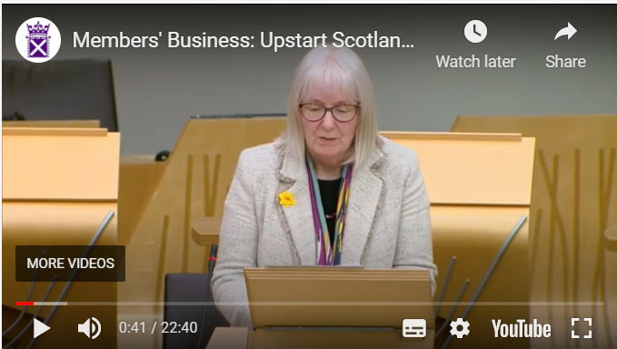
Unfortunately, Maree Todd (Minister for Children and Young People) summed up by suggesting that Scotland is ‘doing it already’. Anyone who understands early child development will recognise that, as long as the P1 SNSA and the educational experiences of most four- to six-year-olds are still ‘schoolified’, that cannot be the case. Fortunately, not everyone agrees and – in the run-up to the Parliamentary Election in March – the Greens, LibDems and Labour parties all included a kindergarten stage in their manifestos. This is a significant first in UK politics.
In an election hustings event, organised by Kate Johnston on 24-4-21, there was further evidence of a real step forward in political understanding about developmentally-appropriate care and education for the under-sevens. The indications are, however, that the newly-elected government has yet to see the light so we shall carry on trying to persuade them.
A Year of Childhood in the middle of a pandemic
In late 2020 the Children’s Parliament persuaded the Scottish government to name 2021 ‘The Year of Childhood’ in celebration of the forthcoming incorporation of the United Nations Convention on the Rights of the Child into Scots law. Upstart supported this initiative wholeheartedly but we have been disappointed that policymakers have not taken it to heart.
Despite the ill-effects of the pandemic on children’s health and well-being, which may have very worrying long-term implications
- some local authorities are still refusing to grant funded deferral of school entry for four-year-olds
- the Scottish government is still requiring schools to continue national standardised assessments in literacy and numeracy for five-year-olds who have missed out on about a quarter of their early childhood
- the academic ‘catch-up’ narrative, which originated in England, is still influencing far too many policy-makers at all levels.
Upstart has supported all moves to put children’s well-being at the heart of the recovery from the COVID19 pandemic and will continue to do so.
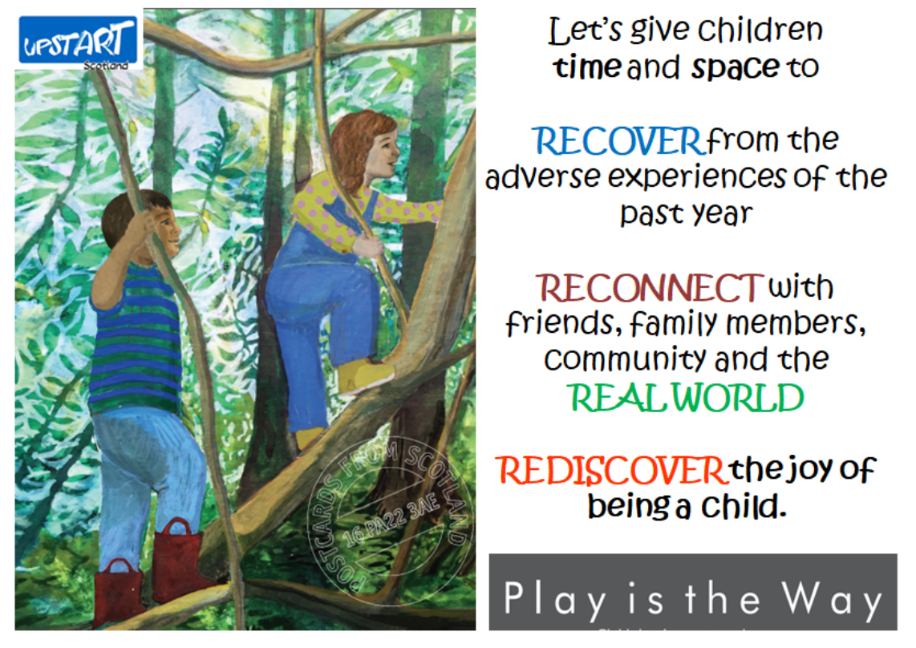
Play is the Way: Little Book of Quotes
There’s recently been another off-shoot of Play is the Way. The charity CosyFund contacted us to ask if there was some way they could help promote Upstart in our fifth anniversary year . It happened that a supporter called Bryony Date was posting illustrations on our website, each accompanied by a quotation about play and child development. They were proving very popular with Twitter-followers so I suggested Cosy Fund might put some into a little book. I contacted Bryony who agreed the book could be a good way to spread information and inspiration about early child development. She has now collected 45 illustrated quotes, with academic references and they went off to Cosy Fund on 2-6-21. We are awaiting further developments.
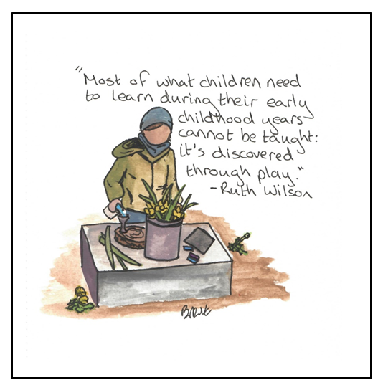
Other activities
Since the last AGM we have also:
- celebrated the fifth anniversary of our launch
- held four Board Meeting, via Zoom
- provided speakers for many online meetings and webinars provided by schools, settings, further education establishments and third sector organisations
- attended scores of other online meetings, to ensure an Upstart presence, make contacts with like-minded organisations and keep ourselves up-to-date
- continued to publish monthly Newsletters and at least one blog per month (usually by guest authors) and to grow our following on Upstart’s Facebook pages and Twitter (now almost 11K followers).
Sue Palmer, Chair of Upstart Scotland, 2nd June 2021

